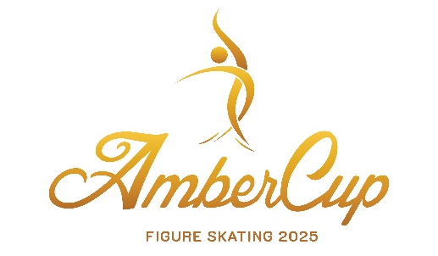

AMBER CUP 2025
International figure skating competition for single skating
November 20-23, 2025
Riga, Latvia

Plānoto Elementu saraksts/Planned Program Contents
ISU Federācija/ISU Member Federation
Kluba nosaukums/Club
Kategorija/Category
Sportista vārds, uzvārds/Name of Competitor
Treneris/Coach
ELEMENTI IZPILDĪŠANAS SECĪBĀ/ELEMENTS IN ORDER OF SKATING

Elementi īsā programma / Elements SP
1
2
3
4
5
6
7

Elementi izvēles programma / Elements FS
1
2
3
4
5
6
7
8
9
10
12
13

Lūdzam nosūtīt Organizatoriem līdz 10.11. 2025/To be sent to Organizing Committee by email until November 10th , 2025: rigaambercup@inbox.lv

