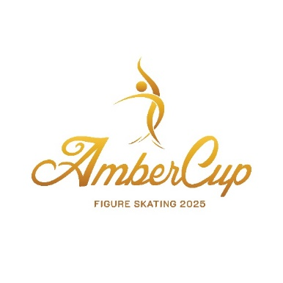

**AMBER CUP 202****5**

Interclub figure skating competition for single skating and elements

**November 20-23, 2025, Riga, Latvia**

**Dalībnieku saraksts/Entry list**

Pieteikums klubiem, kas piesaka **10 vai vairāk dalībniekus**. Ja sportistu skaits ir mazāks, lūdzu, izmantojiet elektronisko pieteikšanās formu: <https://forms.gle/S19VR19tnGFm4vjm8>.

Application for clubs registering **10 or more participants**. If the number of athletes is smaller, please use the electronic registration form: <https://forms.gle/S19VR19tnGFm4vjm8>.

Pieteikumu lūdzam nosūtīt organizatoriem uz epastu [info@rigaambercup.eu](mailto:info@rigaambercup.eu) līdz **2025. gada 15. oktobrim.**

To be sent to the Organizing Committee by email: [info@rigaambercup](mailto:info@rigaambercup).eu until **October 15, 2025.**

|  |  |
| --- | --- |
| ISU Federācija/ISU Member Federation |  |
| Kluba nosaukums/Club |  |
| Kontaktpersonas vārds/Contact person |  |
| Tālrunis/Contact phone number |  |
| Epasts/Email |  |

|  |  |  |  |  |
| --- | --- | --- | --- | --- |
| No. | Vārds/Name | Uzvārds/Surname | Dzimšanas datums/Birth date  dd.MM.yyyy | Kategorija/Category |
| 1. |  |  |  |  |
| 2. |  |  |  |  |
| 3. |  |  |  |  |
| 4. |  |  |  |  |
| 5. |  |  |  |  |
| 6. |  |  |  |  |
| 7. |  |  |  |  |
| 8. |  |  |  |  |
| 9. |  |  |  |  |
| 10. |  |  |  |  |
| 11. |  |  |  |  |
| 12. |  |  |  |  |
| 13. |  |  |  |  |
| 14 |  |  |  |  |
| 15. |  |  |  |  |
| 16. |  |  |  |  |
| 17. |  |  |  |  |
| 18. |  |  |  |  |
| 19. |  |  |  |  |
| 20. |  |  |  |  |